Welcome
Today’s Date: _________/______/_________

Patient’s Name: ___________________________________

Preferred Name: __________________ Male/Female

Birth Date: ___/___/___ Age: ____ SS # _______________

Mailing Address: __________________________________
________________________________________________
City State Zip

Home # ________________ Work # _______________
Other # ________________ Cell # ________________

What days and times do you prefer your appointments?
________________________________________________

Email Address: ___________________________________
How did you hear about us? ________________________
_______________________________________________
Employer: ______________________ How Long? _______
________________________________________________
City State Zip
Occupation: ______________________________________

Approximately when was your last dental visit (circle one): 6 months 1 year 1-2 years 2-5 years 5-10 years

What were you treated for? ______________________________________________

Where is your preferred pharmacy? ___________________________________________
Name City State

Status: Minor/Single/Married/Divorced/Separated/Widowed
(Please Circle Answer)
Spouse’s Name: __________________________________
Do you have any children? Yes/No How Many?________
Primary Dental Insurance

Insured’s Name: ____________________
Relation: ___________ DOB __/___/____
Insured’s Employer: _________________

Co. Name: ________________________
Address: __________________________
_________________________________
City State Zip

Phone: ___________________________
Insured SS # _______________________
ID # ______________________________
Group # (Plan, Local or Policy #)
_________________________________

Secondary Dental Insurance

Insured’s Name: ____________________
Relation: ___________ DOB __/___/____
Insured’s Employer: _________________

Co. Name: ________________________
Address: __________________________
_________________________________
City State Zip

Phone: ___________________________
Insured SS # _______________________
ID # ______________________________
Group # (Plan, Local or Policy #)
_________________________________

Person ultimately responsible
Name: ____________________________
Relation: ___________________________
Billing Address: _____________________
__________________________________
City State Zip
SS#: ______________________________
Driver’s License # ____________________
Work # ____________________________
Payment Method: Cash/Check/Credit Card
____ I hereby authorize assignment of my insurance rights and benefits directly to the provider for services rendered. I fully understand I am solely responsible for any balance not paid by my insurance company (if offered at this office).
IN THE EVENT OF AN EMERGENCY
Who should we contact? ___________________________
Relation: ___________________________
Home Phone #: ___________________________
Work Phone #: ___________________________

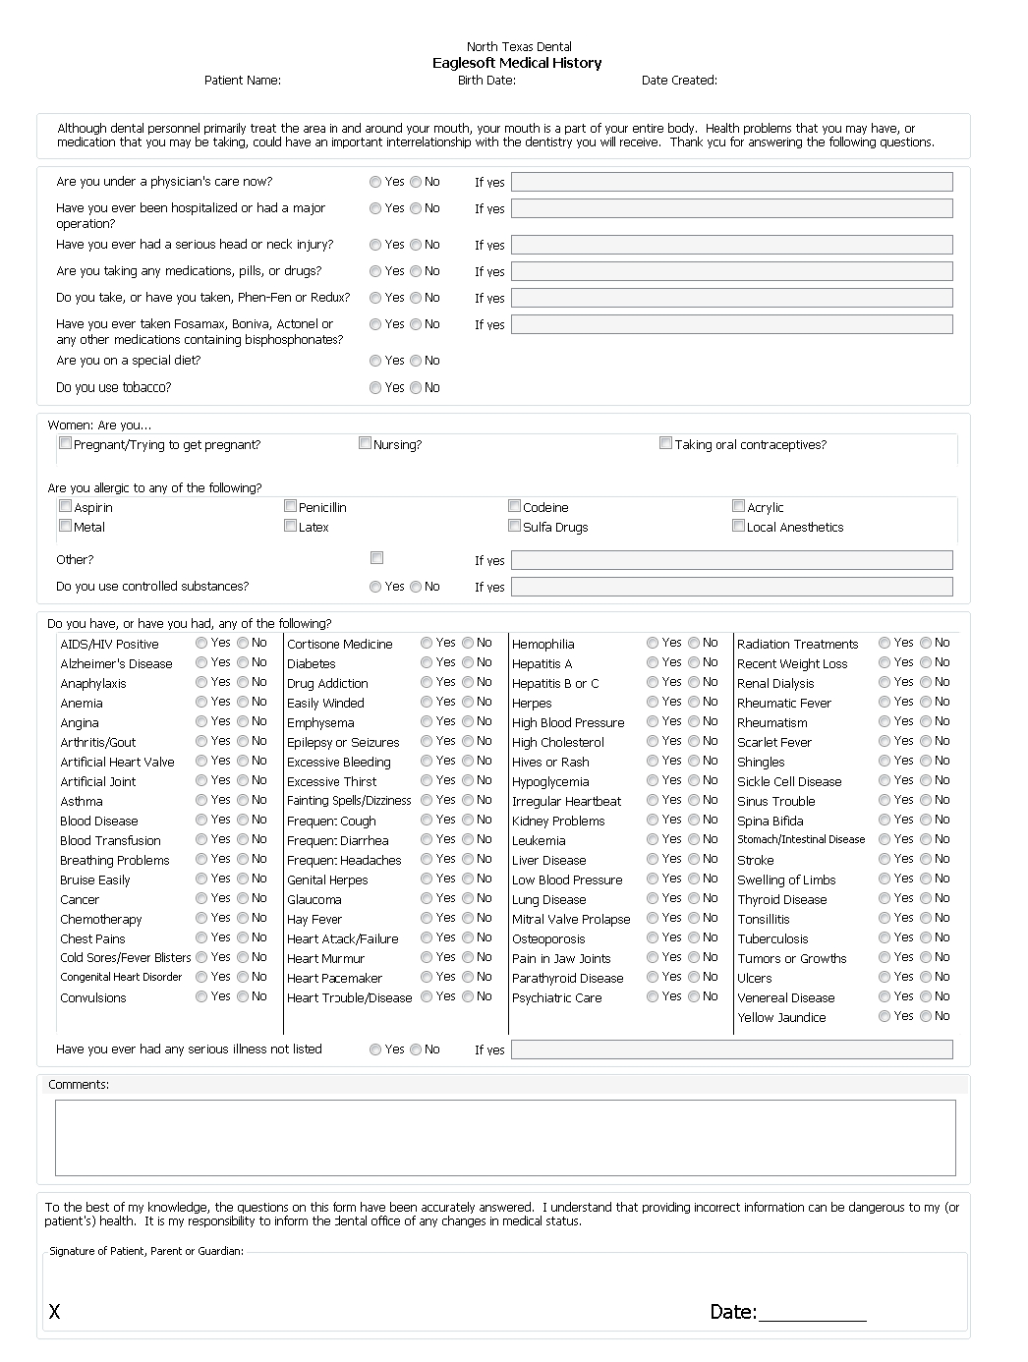

ATTENTION ALL INSURANCE PATIENTS:
PLEASE READ THIS PAGE CAREFULLY IN ITS ENTIRETY!

AUTHORIZATION TO RELEASE
AND
AUTHORIZATION OF ASSIGNMENT OF BENEFITS

We strongly feel that all patients deserve the very best dental care that we can provide. Furthermore, we feel that everyone benefits when definitive financial arrangements are agreed upon. Accordingly, we have prepared this material to acquaint you with our policy.

OUR PROFESSIONAL SERVICES ARE RENDERED TO YOU, NOT THE INSURANCE COMPANY.
THEREFORE, PAYMENT FOR TREATMENT IS YOUR RESPONSIBILITY.

Please read and sign the following:
- I authorize NTD to release or receive any information necessary to expedite my insurance claims.
- I hereby authorize NTD to bill my insurance company directly for their services.
- I authorize payment directly to NTD of any insurance benefits otherwise payable to me.
- In the event I receive payment from my insurance carrier, I agree to endorse any payment I receive over to NTD for which these fees are payable.
- I understand that there are provisions and exclusions in my dental plan that may prevent payment for my procedures. I also understand that my insurance may not inform the provider of these provisions and exclusions upon benefit verification.

I understand that it is up to me to inform NTD of my insurance eligibility, waiting periods and benefits. I also understand that this office cannot guarantee my insurance status in any of these areas. Any insurance estimate or information given to me by the staff at NTD is NOT a guarantee of actual insurance payment. I also understand that any insurance claim not paid in full after 60 days will become my responsibility to be paid at that time.

Patient Signature_____________________________ Date ______________________
Staff Signature_______________________________

APPOINTMENT POLICY

We are glad you have chosen us to provide your dental care, but if you miss your appointments, you compromise your care. We want to remind you of our office policies regarding missed appointments.
A missed appointment is when you fail to show for an appointment without a phone call, or cancel without at least 24-hour notice.
A doctor/patient relationship is built on mutual trust and respect. As such, we strive to be on time for your scheduled appointments, and ask that you give us the courtesy of a call when you are unable to keep your appointment.
In the event an appointment is failed without this 24 hour notice, a fee of $25 will be charged to your account. We understand that circumstances arise and we will take these into consideration.
I HAVE BEEN INFORMED OF AND AGREE TO COMPLY WITH THIS PAYMENT
AND APPOINTMENT POLICIES OF NTD

Patient Signature_____________________________ Date ______________________
Staff Signature_______________________________
FINANCIAL POLICY

Our goal at North Texas Dental (NTD) is to provide the finest quality dental care available to our patients. We offer the best in sterilization, laboratory and clinical techniques currently used in the dental field today. We do not want this quality compromised by overhead expenses. In order to keep these expenses to a minimum, we ask the following:
Payment is required at the time services are rendered. Payment can be made using the following payment types:
- Cash
- Personal/Local Checks. Local checks will be accepted with proof of driver’s license of the person writing the check. This person must be present at the time the check is written. A $35 service charge will be charged for all return checks.
- Credit Cards: Our office accepts most major credit cards
- Care Credit: No interest plans are available through an outside financing company for up to 12 months. They offer low monthly payments with no annual fees or pre-payment penalties. Please ask our Financial Coordinator if you are interested.
Please understand that beginning the first day of the month following balances becoming ninety (90) days past due, a monthly finance charge will be assessed to any unpaid balance. In the case of default of payment on this account, the responsible party agrees to pay collection costs and attorney fees incurred in attempting to collect in this amount or any future outstanding balances.
REFUNDS FOR UNFINISHED TREATMENT: Please understand that if a patient decides to discontinue treatment after it has been started, a full refund will NOT be given. Individual circumstances may be discussed with the Office Manager and/or Dentist.
CREDIT ON AN ACCOUNT: If an insurance company pays more than anticipated creating a credit for the patient, we are happy to either refund the patient or leave a credit on the account to be applied towards future treatment.

I accept full financial responsibility for this account and for all dentistry performed upon myself and my dependents in this dental office.

Patient Signature_____________________________ Date ______________________
Staff Signature_______________________________

ACKNOWLEDGMENT OF PRIVACY PRACTICE

My signature confirms that I have been informed of my rights to privacy regarding my protected health information, under the Health Insurance Portability & Accountability Act of 1996 (HIPPA). I understand that this information can and will be used to:

- Provide and coordinate my treatment among a number of health care providers who may be involved in that treatment directly or indirectly.
- Obtain payment from third-party payers for my health care services.
- Conduct normal health care operations such as quality assessment and improvement activities.

I have been informed of my dental provider’s Notice of Privacy Practices containing a more complete description of the uses and disclosures of my protected health information. I have been given the right to review and receive a copy of such Notice of Privacy Practices. I understand that my dental provider has the right to change the Notice of Privacy Practices and that I may contact this office address above to obtain a current copy of the Notice of Privacy Practices.

I understand that I may request in writing that you restrict how my privacy information is used and disclosed to carry out treatment, payment or health care operations and I understand that you are not require to agree to my requested restrictions, but if you do agree then you are bound to abide by such restrictions.

Patient Name: ________________________________ Date: _______________

Signature: __________________________________

Relationship to Patient: ________________________

